IAME Series Asia 2024
ACCOMMODATION FORM

Guest name:
Email: | Tel:
Check-in Date: | Check-out Date:
Arrival Flight / Time: | Departure Flight / Time:
No. of Room (s): | No. of Guests:
Room Preferences: | [ ] King size bed | [ ] Twin bed
 | [ ] Sofa bed (THB 750 per room per night)

Group Period | Total Nights | Room Type | Total Rooms | Room Rate (room/night)
13-18 March 2024  (Wednesday-Saturday) | 3 | Deluxe Seaview | TBA | THB 4,200 net included breakfast for 2 persons
24-29 April 2024  (Wednesday-Saturday) | 3 | Deluxe Seaview | TBA | THB 4,900 net included breakfast for 2 persons

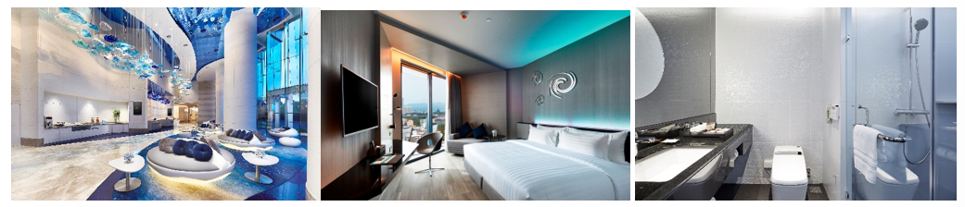

Deluxe Seaview, 34 sq.m. At 34 square meters, with space for up to two people and a child. Stay fresh with a 4-figure bathroom that has a rain shower, and don't forget to unwind with your balcony that overlooks the Pattaya Ocean.

Privileges for Guests who stay in Deluxe Sea View
- Complimentary Breakfast buffet at Waves & Wind Restaurant.
- Complimentary WIFI Internet Access in room and public area.
- Complimentary Hotel Facilities (Swimming Pool, Water park, Fitness).
- Complimentary 4 bottles of drinking water per day.
- Complimentary daily mini-bar (Snacks & Soft drinks)
- Complimentary in-room coffee & tea.

Check In & Check Out Time, Early Check In & Late Check Out Time
- Check in time after 14:00 hrs., however we reserve the right upon the room availability.
- Extra charges for early check-in from 7:00 to 13:59 = 50% of the contract rate.
- Extra charges for early check-in from 0:01 to 6:59 = 100% of the contract rate.
- Check out time before 12:00 hrs. (noon).
- Extra charges for check-out after 12:01 to 18:00 = 50% of the contract rate.
- Extra charges for check out after 18:01 = 100% of the contract rate.

Rate Condition Guestroom rates quoted are inclusive of 10% service charge and applicable government tax on room rate, effectively a total of 17.7%.

TRANSFER SERVICE

The Hotel is approximately 110 km from Suvarnabhumi International Airport and provides Limousine service from the airport to the Hotel at the following rates:

- Toyota Camry [ ] THB 3,100. - net / car / one way (Max. 2 persons with luggage).
- Mercedes Benz E Class [ ] THB 5,800. - net / car / one way (Max. 2 persons with luggage)
- VIP Van-Toyota Commuter [ ] THB 3,500. - net / van / one way (Max. 7 persons with luggage).

[ ] Pick Up Date:__________________________ Flight / Time: ________________________ Car Type:_________________

[ ] Drop Off Date:__________________________ Flight / Time: ________________________ Car Type: _________________

*Rates are inclusive of 10% service charge and 7% applicable government tax

The Hotel is approximately 110 km from Don Muang International Airport and provides Limousine service from the airport to the Hotel at the following rates:

- Toyota Camry [ ] THB 3,500. - net / car / one way (Max. 2 persons with luggage).
- Mercedes Benz E Class [ ] THB 6,300. - net / car / one way (Max. 2 persons with luggage)
- VIP Van-Toyota Commuter [ ] THB 4,300. - net / van / one way (Max. 7 persons with luggage).

[ ] Pick Up Date:__________________________ Flight / Time: ________________________ Car Type:_________________

[ ] Drop Off Date:__________________________ Flight / Time: ________________________ Car Type: _________________

*Rates are inclusive of 10% service charge and 7% applicable government tax

PAYMENT AND BILLING PROCESS
Pre-Payment the Party shall settle full payment of each booking at the time of booking by credit card. Hotel will send the payment link by email.

Cut-off Date
The final cut-off date for accommodation rooms by March 1st, 2024 (13-18 March)
The final cut-off date for accommodation rooms by March 15th, 2024 (24-29 April)

When the cancellation request is received by the Hotel | Cancellation fees
less than 7 days and the event date | 100% of the contracted accommodation charge for all room nights canceled

Contact person:
Sales team: Ms. Yuvadee Vittavuspong Email: yuvadee.v@gcphotels.com please CC: rsvn_pattaya@gcphotels.com

